Type your article title here [Arial 14]
First Author¹*; Second Author²; etc. (Times New Roman 11; single spacing)
1stauthor's affiliation: Department/Faculty, Name of Institution, Country
2nd author's affiliation: Department/Faculty, Name of Institution, Country

* corresponding author's email (Times New Roman 10; single spacing)

ABSTRACT (Times New Roman 12)
Type the English abstract here, using Times New Roman font 11 (single spacing). The content of the abstract includes background, objective, method, study/research findings, conclusion, and suggestion. The abstract is written in a single paragraph, without citations or reference sources. Word count for the abstract is 200–300 words. An abstract presented separately from the article, so it must be able to stand alone, and should be written as a single paragraph without header. For this reason, References should be avoided. Also, non-standard or uncommon abbreviations should be avoided, but if essential they must be defined at their first mention in the abstract itself.
Keywords: Keyword one; Keyword two; Keyword three; etc. (written in English; 3–7 keywords)

p-ISSN : 2088-7310
e-ISSN : 2614-3534

Submitted : dd-mm-yyy
Accepted : dd-mm-yyy
Published : dd-mm-yyyy

Start page - end page

DOI Artikel:
https://dx.doi.org/_____________/_______

Publisher:
Libraria:
Jurnal Ilmu perpustakaan dan Informasi

Contact:
https://libraria.fppti-jateng.or.id/index.php/lib/about/contact



FPPTI Jawa Tengah
UPT Perpustakaan dan UNDIP Press, Universitas Diponegoro
Jl. Prof. Soedarto, Tembalang, Kec. Tembalang, Kota Semarang, Jawa Tengah 50275 Indonesia
Email: journal@fppti-jateng.or.id

INTRODUCTION (Times New Roman 12

The content of the introduction is written in Times New Roman 11 font (1.5 line spacing). The introduction describes the research background and objectives, supported by theories relevant to the issues raised. The content of the introduction emphasizes the urgency and uniqueness of the research problem to be further examined by the author/researcher. Uniqueness refers to the existence of differences or distinct characteristics of the research currently being conducted compared to other studies that have been conducted previously.

LITERATURE REVIEW (Times New Roman 12)
Literature review if there are sub-headings (see Headings in author guidelines). Sub-headings in the literature review are written in Times New Roman 11 font (1.5 line spacing). The content of the literature review includes theories and scientific opinions relevant to the core issue. This section includes the strengths and weaknesses of previous studies that can serve as arguments that the current research aims to refine or develop past research. This section also includes theoretical foundations in the form of a summary of theories from literature supporting the research, as well as explanations of basic concepts and principles required for problem-solving.
Note: Writing this literature review section is optional (not mandatory; it can be written/discussed directly in the results and discussion section).

METHOD (Times New Roman 12)
The content of the method section is written in Times New Roman 11 font (1.5 line spacing). The method represents techniques for data collection, processing, and analysis. The content of the method covers data sources, time of data collection, population and sample, data presentation, and data analysis techniques. This method determines the sharpness of data analysis results in the results and discussion section of the research.

RESULTS AND DISCUSSION (Times New Roman 12)
Results and discussion are written in Times New Roman 11 font (1.5 line spacing). Results are not raw data, but data that has been processed and interpreted in the form of statistical data, whether in tables, graphs, charts, sketches, or photographs combined with relevant theory. Meanwhile, discussion represents the result of data analysis based on relevant theory. The content of results and discussion must answer research problems and discover appropriate analysis to provide solutions/positive impacts on the development of science and technology in society. Results and discussion if there are sub-headings (see Headings in author guidelines).
Formatting for table titles (Times New Roman 11) and table content (Times New Roman 10; single line spacing). Table titles are written above the table and arranged sequentially within a single manuscript, for example Table 1, Table 2, Table 3, etc. If citing tables from other readings/references, the source must be included.

Table 1. Table Title Written Clearly and High Resolution Display
No Data 1 Data 2 Data 3 etc...
1. Data 1 Data 1 Data 1
2. Data 2 Data 2 Data 2
3. Data 3 Data 3 Data 3
etc... etc... etc... etc...
Source: Reference (2017)

Figure titles (Times New Roman 11) are written below the figure. Other objects included as figures include graphs, charts, sketches, and photographs. Figure titles are arranged sequentially within a single manuscript, for example Figure 1, Figure 2, Figure 3, and so on. If citing figures from other readings/references, the source must be included.
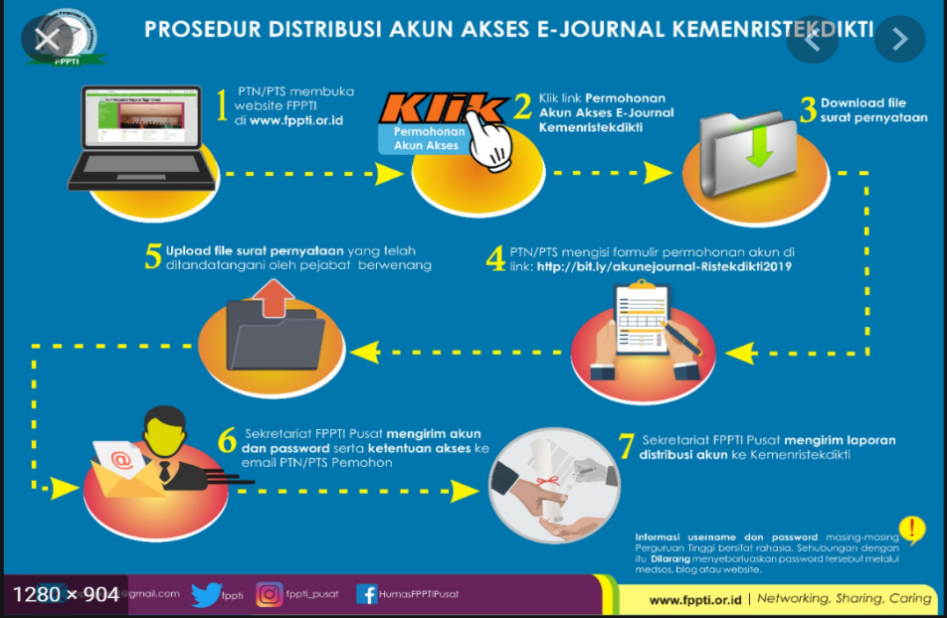
Figure 1. E-Journal Access Account Distribution Procedure Kemenristekdikti
Source: www.fppti.or.id/main/index/1

CONCLUSION (Times New Roman 12)
The content of the conclusion is written in Times New Roman 11 font (1.5 line spacing). The conclusion represents the essence of research results and discussion. The conclusion content is not accompanied by theories/citations. The conclusion emphasizes information on research impact, benefits, and research recommendations.
USE OF GENERATIVE AI AND AI-BASED TECHNOLOGIES (Times New Roman 12)
- If using AI in the writing process:
written in Times New Roman 11 font (1.5 line spacing). Example: During the preparation of this work, the author(s) used language model tools to assist with language refinement and final text proofreading. After using such tools, the author(s) reviewed and edited the content thoroughly and take full responsibility for the final version of this manuscript.
- If not using AI. Example:
The author(s) declare that no Generative AI technology or artificial intelligence tools were used in the research process, preparation, or writing of this manuscript.

FUNDING (Times New Roman 12)
- If funded. Example: This research was funded by XYZ
- If not funded. Example: This research was conducted independently and did not receive funding, grants, or sponsorship from any institution.

CONFLICT OF INTEREST (Times New Roman 12)
- If having a conflict of interest:
- Financial / Commercial
Used if the author works in a related company, serves as a consultant, or holds shares/ownership in the product/technology studied. Example: The author declares a financial/commercial interest as serving as (specify position) at (Company/Institution Name), which holds patent rights or produces the technology discussed in this article.
- Receipt of Honorarium / Grant / Material Support
Used if the author receives funds, remuneration, or special facilities from sponsors interested in the research results. Example: The author received (honorarium / research grant / sample support) from (Company/Institution/Sponsor Name). However, (Company/Institution/Sponsor Name) was not involved in the research design, data collection, analysis, or manuscript preparation decisions.
- Leadership Role / Institutional Affiliation
Used if the author serves as an officer, board member, or founder of the institution studied/interested. Example: The author is a (Founder / Member of Board of Directors / Leader) of (Organization/Company/Institution Name), whose outcomes may be influenced by or influence evaluation in this study.
- General Statement Formula (can be adjusted)
If declaring potential conflicts of interest concisely and flexibly. Example: The author discloses the following potential conflicts of interest: (specify relevant relationships, support, or positions). Nevertheless, all analysis and conclusions were drawn independently and objectively.
- If having no conflict of interest:
Example: The author declares no conflicts of interest to disclose.

ACKNOWLEDGEMENTS (Times New Roman 12)
The contents of acknowledgements are written in Times New Roman 11 font (1.5 line spacing). This section is dedicated to acknowledging individuals or institutions that provided technical assistance, field/data access, research facilities, or substantive feedback but do not meet the criteria for authorship.

REFERENCES (Times New Roman 12)
References must be formatted according to APA Style (7th Edition) in Times New Roman 11 pt with single line spacing (1.0), with each reference entry separated by a single enter. The reference list must contain a minimum of 15 titles, consisting of 80% primary sources and 20% secondary sources. Active DOI URLs must be included for every journal article reference that has one. Authors are required to use reference manager software (such as Mendeley, Zotero, or EndNote) to ensure citation consistency. Every source cited in the body text must be listed in the reference section. (For detailed guidelines on various reference types, please refer directly to the official APA Style 7th Edition Reference Examples).

Internet Sources:
- Used for webpages, news articles, or publication documents with content that is permanent and not designed to change continuously over time.
Example:
IFLA. (2024). Generative AI for library and information professionals. International Federation of Library Associations and Institutions. https://www.ifla.org/g/ai/generative-ai/
- Used for webpages whose data is updated regularly without a historical archive of previous versions (such as real-time statistical dashboards, interactive maps, or frequently updated profile pages).
Example:
Stanford Institute for Human-Centered AI. (n.d.). Artificial intelligence index and policy resources. Stanford University. Retrieved October 21, 2026, from https://hai.stanford.edu/ai-index

Journal Article Source:
Michalak, R., & Ellixson, D. (2026). Reimagining libraries in the AI era : ethical AI literacy and human – centered strategies. AI & SOCIETY, 41(5), 5057–5077. https://doi.org/10.1007/s00146-025-02827-4

E-book Source:
Erik, H. (2024). AI Revealed. Berlin, Boston: Mercury Learning and Information. https://doi.org/10.1515/9781501520631

Print Book Source:
Smith, J. A., & Davis, M. R. (2025). Academic libraries in the age of artificial intelligence (2nd ed.). Routledge.

